***Requirements Validation – I***

***Lectures # 16***

***Today’s Topics***

* Requirements validation
* Validation techniques

***Requirements Engineering Process***

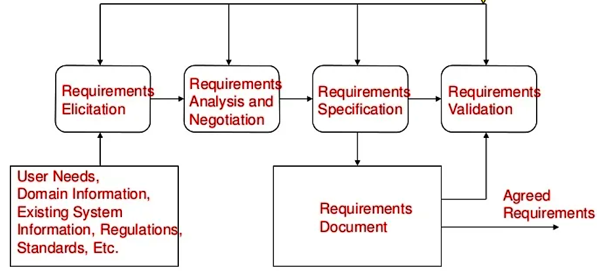

***Validation Objectives***

* Certifies that the requirements document is an acceptable description of the system to be implemented
* Checks a requirements document for
  + Completeness and consistency
  + Conformance to standards
  + Requirements conflicts
  + Technical errors
  + Ambiguous requirements

***Analysis and Validation***

* Analysis works with raw requirements as elicited from the system stakeholders
  + “Have we got the right requirements” is the key question to be answered at this stage
* Validation works with a final draft of the requirements document i.e., with negotiated and agreed requirements
  + “Have we got the requirements right” is the key question to be answered at this stage

***Validation Inputs and Outputs***

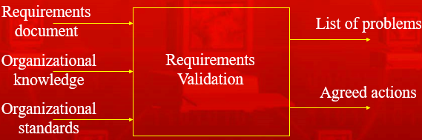

***Requirements Document***

* Should be a complete version of the document, not an unfinished draft. Formatted and organized according to organizational standards

***Organizational Knowledge***

* Knowledge, often implicit, of the organization which may be used to judge the realism of the requirements

***Organizational Standards***

* Local standards e.g., for the organization of the requirements document

***List of Problems***

* List of discovered problems in the requirements document

***Agreed Actions***

* List of agreed actions in response to requirements problems. Some problems may have several corrective actions; some problems may have no associated actions

***Requirements Reviews***

* A group of people read and analyze the requirements, look for problems, meet and discuss the problems and agree on actions to address these problems

***Requirements Review Process***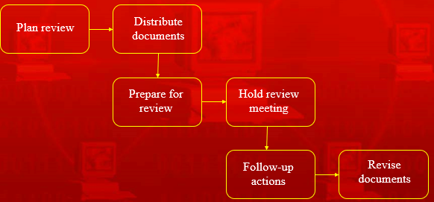

***Review Activities***

***Plan review***

* + The review team is selected and a time and place for the review meeting is chosen

***Distribute documents***

* + The requirements document is distributed to the review team members

***Prepare for review***

* + Individual reviewers read the requirements to find conflicts, omissions, inconsistencies, deviations from standards and other problems

***Hold review meeting***

* + Individual comments and problems are discussed and a set of actions to address the problems is agreed

***Follow-up actions***

* + The chair of the review checks that the agreed actions have been carried out

***Revise document***

* + The requirements document is revised to reflect the agreed actions. At this stage, it may be accepted or it may be re-reviewed

***Problem Actions***

* *Requirements clarification*
* *Missing information*
* *Requirements conflict*
* *Unrealistic requirement*

***Requirements Clarification***

* The requirement may be badly expressed or may have accidentally omitted information which has been collected during requirements elicitation

***Missing Information***

* Some information is missing from the requirements document. It is the responsibility of the requirements engineers who are revising the document to discover this information from system stakeholders

***Requirements Conflict***

* There is a significant conflict between requirements. The stakeholders involved must negotiate to resolve the conflict

***Unrealistic Requirement***

* The requirement does not appear to be implement-able with the technology available or given other constraints on the system. Stakeholders must be consulted to decide how to make the requirement more realistic

***Pre-review Checking***

* Reviews are expensive because they involve a number of people spending time reading and checking the requirements document
* This expense can be reduced by using pre-review checking where one person checks the document and looks for straightforward problems such as missing requirements, lack of conformance to standards, typographical errors, etc.
* Document may be returned for correction or the list of problems distributed to other reviewers

***Pre-review Checking Stages***

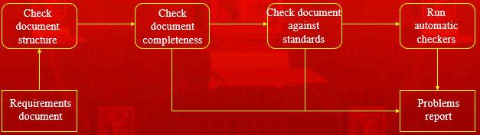

***Review Team Membership***

* Reviews should involve a number of stakeholders drawn from different backgrounds
  + People from different backgrounds bring different skills and knowledge to the review
  + Stakeholders feel involved in the RE process and develop an understanding of the needs of other stakeholders
* Review team should always involve at least a domain expert and an end-user

***Summary***

* Requirements validation should focus on checking the final draft of the requirements document for conflicts, omissions and deviations from standards
* Inputs to the validation process are the requirements document, organizational standards and implicit organizational knowledge. The outputs are a list of requirements problems and agreed actions to address these problems
* Reviews involve a group of people making a detailed analysis of the requirements
* Review costs can be reduced by checking the requirements before the review for deviations from organizational standards. These may result from more serious requirements problems